DOKUZ EYLÜL UNIVERSITY
ENGINEERING FACULTY
DEPARTMENT OF COMPUTER ENGINEERING

CME 2210
Object Oriented Analysis and Design

CEMETREE

by
Boran Bereketli – 2022510105
Bedirhan Yenilmez – 2022510159
Alperen Dönmez – 2022510113
Ramazan Denli - 2022510111

IZMIR
20.05.2024

CHAPTER ONE
INTRODUCTION
Cemeteries have a problem of being unorganized and hard to navigate. Some graves are even unknown. This project aims to solve this by providing a way to store and manage people’s and cemetery’s information. This is a cemetery management and navigation system designed to help finding where people are buried to and get information about them.

The system is designed to store cemetery information and buried people’s information and assist finding and choosing a cemetery. It will be able to connect people, find where their relatives are buried to and indicate their location.

The information about buried people (name, surname, birthdate, death date, relatives, death cause, cemetery information etc.) is stored in a data structure and can be saved and loaded from a file. The records of visitors(id, name, surname, date etc.) can be kept by the system.

The people can be filtered and sorted by their name, surname, age, cause of death. Some statistics such as top death causes, average age of dead people, male/female ratio, cemetery distribution can be provided according to the user’s requests.

This software can be utilized by city managements or countries.

CHAPTER TWO
REQUIREMENTS
2.1 External Interfaces
- Users and administrators can interact with the system.
- Text files are used to read/write data.
2.2 Functions
Functions in Cemetree class:
- public void saveToFile(String fileName) throws IOException { ... }
  - Saves the current state of cemeteries, people, and visitors to CSV files.
- public void loadFromFile(String fileName) throws IOException { ... }
  - Loads cemeteries, people, and visitors from CSV files into the system.
- public List<Person> searchPeopleByFilter(Person filter, boolean includeAlive) { ... }
  - Searches for people matching a filter and includes alive people if specified.
- public List<Cemetery> searchCemeteriesByFilter(Cemetery filter) { ... }
  - Searches for cemeteries matching a filter.

- public List<Person> searchPeopleByDate(List<Person> searchList, Date startDate, Date endDate) { ... }
  - Searches for people who died within a specified date range.
- public List<PersonRelationship> searchRelativesRecursive(int generationInterval, Person person) { ... }
  - Searches recursively for relatives of a person within a specified generation interval.
- public void searchRelativesAncestors(int generationInterval, Person person, Stack<Person> ancestorsStack, List<PersonRelationship> result, String relationship) { ... }
  - Searches recursively for a person's ancestors.
- public void searchRelativesChildren(int generationInterval, Person person, Stack<Person> childrenStack, List<PersonRelationship> result, String relationship) { ... }
  - Searches recursively for a person's children.
- public String showStatistics(Cemetery filter) { ... }
  - Shows statistics about the people in the cemeteries, such as average age, male/female ratio, and death causes.
- private List<Person> searchPeopleByCommand(String command, boolean includeAlive) { ... }
- private Person selectPersonFromCommand(ConsoleReader reader, String command, int commandWordCount, List<Person> selectedPeople, boolean includeAlive) { ... }
  - Lets the user to select a person based on a command and the current list of selected people.
- private Person selectPersonInList(ConsoleReader reader, List<Person> list) { ... }
- private List<Cemetery> searchCemeteriesByCommand(String command) { ... }
- private Cemetery selectCemeteryInList(ConsoleReader reader, List<Cemetery> list) { ... }
- private Cemetery selectCemeteryFromCommand(ConsoleReader reader, String command, int commandWordCount, List<Cemetery> selectedCemeteries) { ... }
  - Lets the uset to select a cemetery based on a command and the current list of selected cemeteries.
- public void consoleMode() { ... }
  - The main method for handling the console interface, managing user input, and executing commands.
Functions in Cemetery class:
- ArrayList<Person> getVisitorList(): Returns visitor list of the cemetery.
- ArrayList<Person> getVisitors(Person person): Returns the visitors of the selected person.
- void printVisitorList(): Prints the visitor list in a formatted string.
Functions in Address class:
- String toString(): Return the address in string format.
Functions in Person class
- Getter and setters of name, surname, id, sex, birthDate, motherId, fatherId, dead, admin, deathDate, cemetery, deathCause
2.3 Performance Requirements
- Relatives are expected to be found in less than 20 seconds.
- Visitor list search must take less than 10 seconds.
- The program is expected to search for people in less than 15 seconds.
2.4 Logical Database/File System Requirements
- The program facilitates reading and writing operations from a text file.
2.5 Design Constraints
- Cemeteries are designed to include 20000 people at most.
- Distant relatives cannot be searched.
- Only administrators can add or remove dead people.
2.6 Software System Quality Attributes
- HashMap and Graph data structures are used to lower wait times.
- Software must be reliable, maintainable, efficient, and testable.
- Software mustn’t crash under any circumstances and give error messages.
2.7 Object Oriented Models
- 2.7.1 Analysis Class Model (Static Model)
- Cemetree class is used to store all people.
- Cemetery class stores all information about the cemetery.
- Person class is used to represent a person.
- Address class stores an address.
- 2.7.2 Analysis Collaborations (Dynamic Model)
- Cemetree is the main class and stores all the cemeteries and all people with connections.
- All people’s information is manipulated from the Cemetree class.

CHAPTER THREE
UML DIAGRAMS

Use Case Diagram
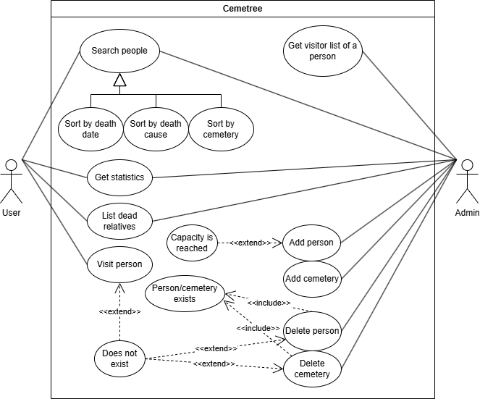
This diagram depicts the general operations the user and admin actors can use. While the user can list relatives, view statistics, search people; the admin can additionally view the visitor records, add people, add cemeteries, delete people and delete cemeteries. Various limits and conditions are also shown like the cemetery capacity and the existence of the person or cemeteries.

Class Diagram

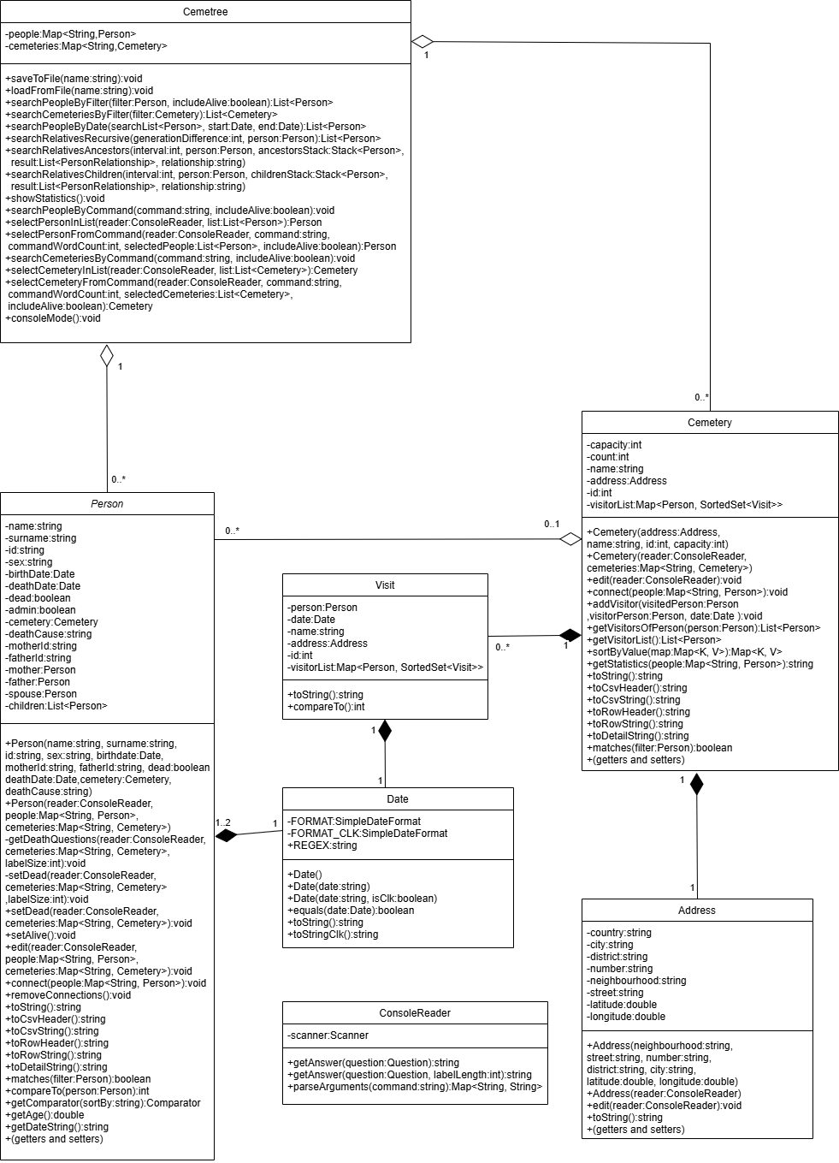
The class structure of the program is shown in the diagram above. The Cemetree class contains all people and cemeteries. Zero or more cemeteries and people can be contained in the class. It is the class where all objects are managed from. The other classes hold the data of their respective types. Person and Cemetery classes hold person and cemetery data. Each cemetery has exactly one address.

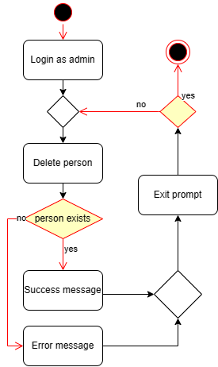
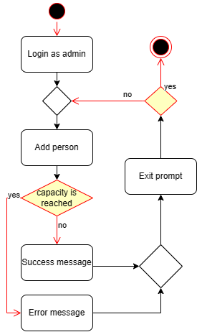
Activity Diagram
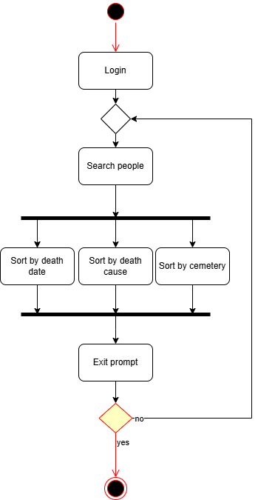

Each activity needs login as the first action.
The deletion of people checks the existence of the person, deletes the person and shows a message to the user.
The addition of people checks the cemetery capacity, adds the person and shows a message to the user.
The results of the search function can be sorted by death date, death cause or cemetery.
An exit prompt is shown after all actions.

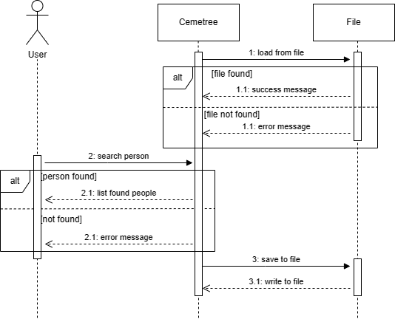
Sequence Diagram

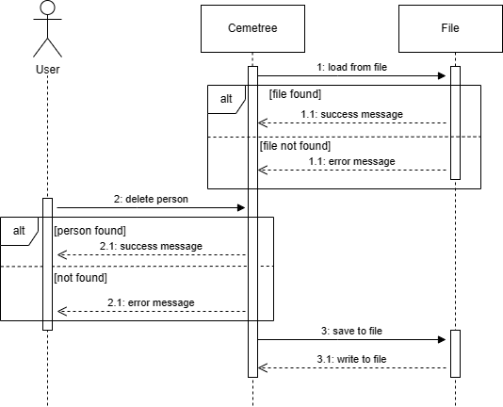

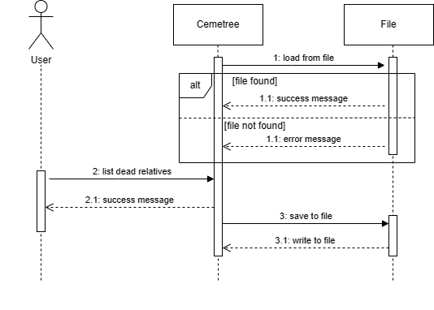
Each diagram has loading from the file as the first action. It returns a message after the file is read.
The first diagram shows the search operation. It shows the list of the matched people.
The second shows the delete operation. It checks if the person exists and returns a message according to the result.
The last diagram depicts the list dead relatives’ function.
All diagrams save the changes to file and show a message according to the result as the last action.

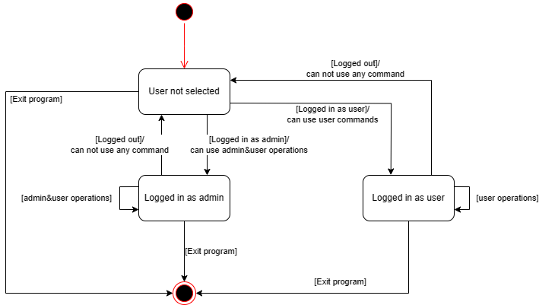
STATE DIAGRAM
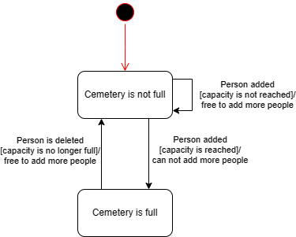
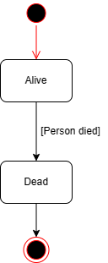

The first diagram shows the login states. The user can login either as user or as admin. User and admin have their respective operations they can use. They can exit the program or log out at any time.
The second diagram shows the cemetery capacity states. It is either full or not full. People can be added when it is not full.
The last diagram shows the state of the person.

CHAPTER FOUR
IMPLEMENTATION
The Cemetree class houses all parts of the system. It has functions to save to file, load from file, search people or cemeteries by using a filter and sort them, search people’s dead relatives, show statistics about all cemeteries, filtered cemeteries or a specific cemetery.
The consoleMode function in the Cemetree class provides 21 unique commands to manage the system. The help command’s output is shown below.
Use help <command> for more information on a specific command.
ADD PERSON Adds a new person
REMOVE PERSON Removes a person
EDIT PERSON Edits a person
SET DEAD Changes a person's status to dead
SET ALIVE Changes a person's status to alive
SET ADMIN Changes a person's admin status
SET USER Changes a person's admin status
SEARCH PERSON Searches for a person (Use "include alive" flag to include alive people at search)
SEARCH RELATIVES Searches for relatives
ADD CEMETERY Adds a new cemetery
REMOVE CEMETERY Removes a cemetery
EDIT CEMETERY Edits a cemetery
SEARCH CEMETERY Searches for a cemetery
SHOW STATISTICS Shows statistics (Use "group" flag to show statistics of all selected cemeteries)
VIEW Views details of a person or cemetery (Use "view person" or "view cemetery" to view corresponding details)
VISIT PERSON Visits a person
GET VISITOR LIST Gets the visitor list of a person
HELP Shows help for <command>
LOGOUT Logs out
CANCEL Cancels current operation
EXIT Exits the program

The rules for the usage of the commands are shown below.
- None of the commands, arguments or flags are case sensitive.
- The command, arguments and flags are seperated by spaces.
- Flags can have spaces.
- Argument keys can not have spaces.
- Argument values need quotation marks if they include spaces.
- An asterisk can be used to use no filters.
Here are some examples:
- COMMAND ARGUMENT_A=<a> ARGUMENT_B=<b> FLAG
- ADD PERSON
- SEARCH PERSON NAME=john BIRTH_DATE=12/02/2008 INCLUDE ALIVE
- SEARCH CEMETERY CITY=İstanbul NEIGHBORHOOD=”Kemer Mahallesi”
- SHOW STATISTICS
- SHOW STATISTICS ID=34-046
- SHOW STATISTICS CITY=İstanbul GROUP
- SHOW STATISTICS * GROUP
- SEARCH RELATIVES INTERVAL=3
- HELP VISIT PERSON

These conditions are checked inside the consoleMode function for each command by using regex expressions.

CHAPTER FIVE
CONCLUSION AND FUTURE WORKS
In this chapter, a summary and future works must be written.

